**DAY -8**

**ChatGPT-powered FAQ Bot (no RAG)**

**1.Overview**

In this project, you will build an AI chatbot using OpenAI’s GPT model inside **Google Colab**. This chatbot can answer any type of question

**2.Tools You Need**

* A **Google account** to use Google Colab.
* An **OpenAI API Key** (from <https://platform.openai.com>).
* A working **internet connection**.

**Step 1: Open Google Colab**

1. Go to **https://colab.research.google.com/** in your web browser.
2. Click on **New Notebook**.
3. Rename it to:  
   **ChatGPT_Powered_FAQ_Bot.ipynb**

**Step 2: Install Required Libraries**

1. In the first code cell, copy and paste this: **! pip install openai gradio**
2. Click the **play ▶️ button** on the left of the cell.
3. Wait until the installation finishes (you'll see "Successfully installed" at the end).

**Output:**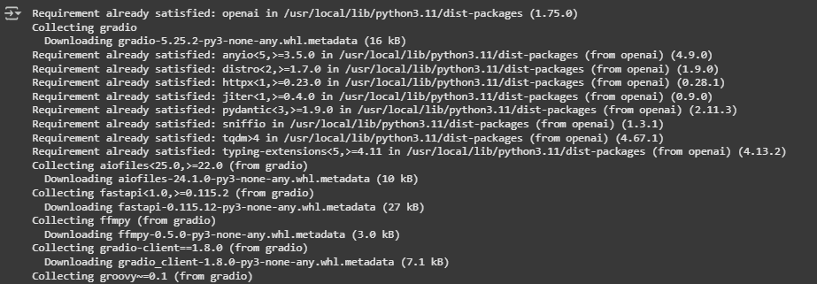

**Step 3: Securely Add Your OpenAI API Key**

1. Add a new code cell.
2. Copy and paste this code:

import os

# Replace YOUR_API_KEY with your actual OpenAI API key

os.environ['OPENAI_API_KEY'] = "YOUR_API_KEY"

1. Replace **YOUR_API_KEY** with your real OpenAI key.
2. Click the **play ▶️ button** to run.

✅ *Tip:* Always keep your API key private!

**Step 4: Create the Chat Function**

1. Add another code cell.
2. Copy and paste this code:

from openai import OpenAI

import gradio as gr

# Initialize OpenAI client

client = OpenAI(api_key=os.getenv("OPENAI_API_KEY"))

# Define the chatbot logic

def chat_with_gpt(user_input):

response = client.chat.completions.create(

model="gpt-4", # You can also use "gpt-3.5-turbo"

messages=[

{"role": "system", "content": "You are a helpful AI assistant."},

{"role": "user", "content": user_input}

],

temperature=0.7

)

return response.choices[0].message.content.strip()

1. Click **▶️** to run the cell.

**Step 5: Build the Chat Interface**

1. Add another code cell.
2. Copy and paste this code:

iface = gr.Interface(

fn=chat_with_gpt,

inputs=gr.Textbox(lines=2, placeholder="Ask me anything..."),

outputs="text",

title="ChatGPT-Powered Assistant",

description="Ask any question — I'm here to help!"

)

# Launch the chatbot

iface.launch()

1. Click **▶️** to run the cell.

Output:

